

**TUNKU ABDUL RAHMAN UNIVERSITY COLLEGE**

FACULTY OF COMPUTING AND INFORMATION TECHNOLOGY

BAIT2133 WEB ENGINEERING

Assignment

**Work in your team:**

Form a group of 2 people.

Discuss the title of web system going to be produce. State:

Library Management System

1. The purposes of the system.

A Library Management System (LMS) gives access to and manages the resources in your library. A well-chosen system will increase library’s efficiency, save valuable administration time, lead to a better learning experience for student and help develop independent learning. Member able to search books by title, author, subject category and also able to borrow book recorded by this system.

1. The structure of the project team.
2. The scope of the system.

-Create distinct system users based on their roles and permissions.

-System have database that can view list of books status.

-Librarian can manage the system such as add or delete books.

-Providing check-out, return and renew function to borrower.

1. Draft a plan to decide the activities involved in the development.

**Requirements Analysis.** Firstly, every member of the library should be able to borrow a book, return a book, and renew. Secondly, Each book will have a unique identification number and other details including a track number which will help to physically locate the book and search books by their title, author, subject category as well by the publication date. Thirdly, librarian management should be able to do member registration, login, member and books information modification, user permissions and other functions. Forth, The system should be able to retrieve information like who took a particular book or what are the books checked-out by a specific library member and collect fines for books returned after the due date. Finally, The system should be able to send notifications whenever the reserved books become available, as well as when the book is not returned within the due date.

**Design Methods.** 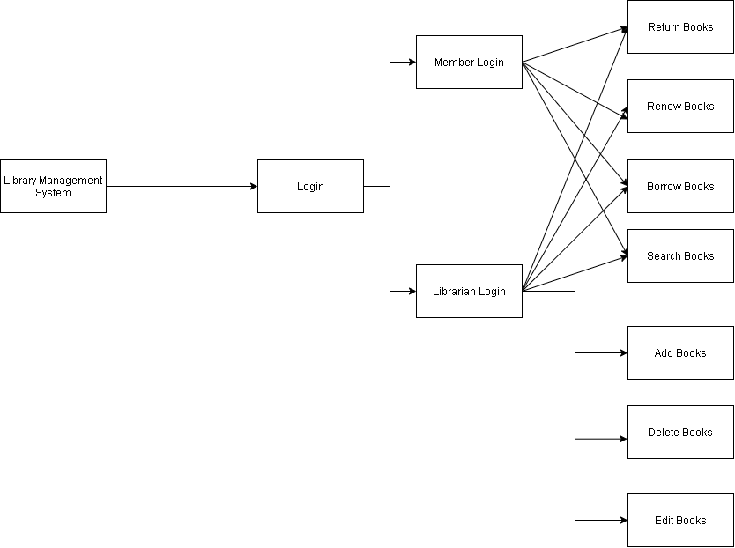

**Construction methods.** Firstly, MYSQL is used as a database, so it is simple to manage and retrieve. records by basic queries that are easy to understand in English and easy to write. Secondly, HTML (Hypertext Markup Language) is the code that is used to structure a web page and its content. HTML is the standard markup language for documents designed to be displayed in a web browser used to specify whether a web content should be recognized as a paragraph, list, heading, link, image, multimedia player, form, or one of many other available elements or even a new element. Thirdly, PHP Preprocessor for Hypertext A frequently used general-purpose open source scripting script Language that is best suited for web creation and development In HTML, it can be embedded. The best things about using PHP are This is because it is incredibly easy for a beginner, but it offer many advanced features for a professional programmer. Forth, Cascading Style Sheets ( CSS) is a stylesheet language used to describe the HTML or XML (including XML dialects such as SVG or XHTML) presentation of a document. CSS specifies how the elements on screen, on paper, in voice, or in other media should be made. Fifthly, JavaScript is a high-level dynamic programming language focused on prototypes, multi-paradigms and interpreted, with weak typing. JavaScript is a dynamic programming language that can dynamically communicate with websites when added to an HTML document.

**Testing methods**. Software testing plays an important role in the software lifecycle. software testing is in the operation and maintenance phase, and it is an important means to ensure the quality of the software before the software products are delivered to the user.Test methods involve the method of running a programme or application in order to identify the use of software errors (errors or other defects). The test object focus on some important function. Firstly, Test the administrator login page whether can login and if enter wrong password will display suggest re-enter. Secondly, if successful entering the account, enter book adding feature modules on the administrator page and view if the new book information is active when adding books and delete book feature if the book is not available, the book does not existed promptly. When you successfully locate the library and confirm the deletion, you can see if the book has been successfully deleted in the query module. User Management Administrators can handle details of users, adjust user privileges, log users out, and even initialise passwords of user login. But users can not be included at will by administrators. Finally, test for borrowing book and returning book function, After the user login successfully, select the borrow function, enter the correct information of the book, you can achieve the function of borrowing books. If you return the book that is not borrowed, it will suggest if you borrowed this book or return the book once again. And at the same time, system updates the book borrow information.